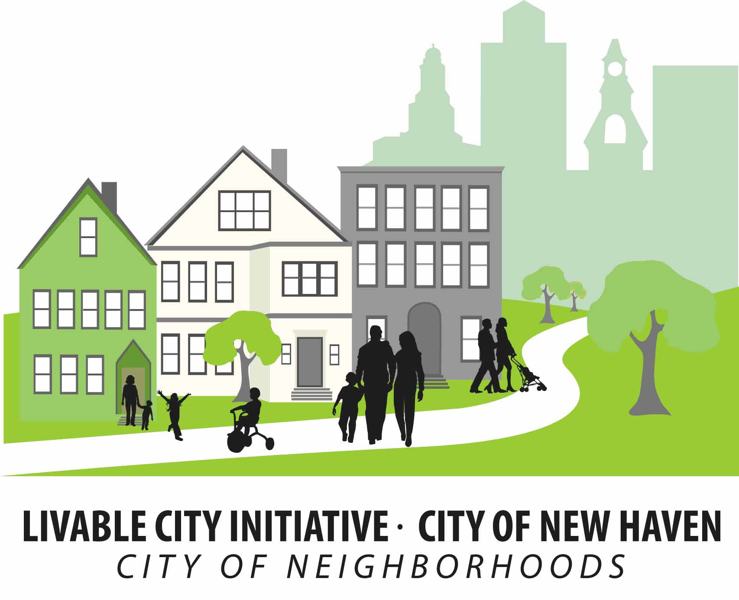 | CITY OF NEW HAVEN  Justin Elicker, Mayor  LIVABLE CITY INITIATIVE  165 Church Street, 3rd Floor  New Haven, CT 06510  Phone: (203) 946-7090 Fax: (203) 946-4899 | 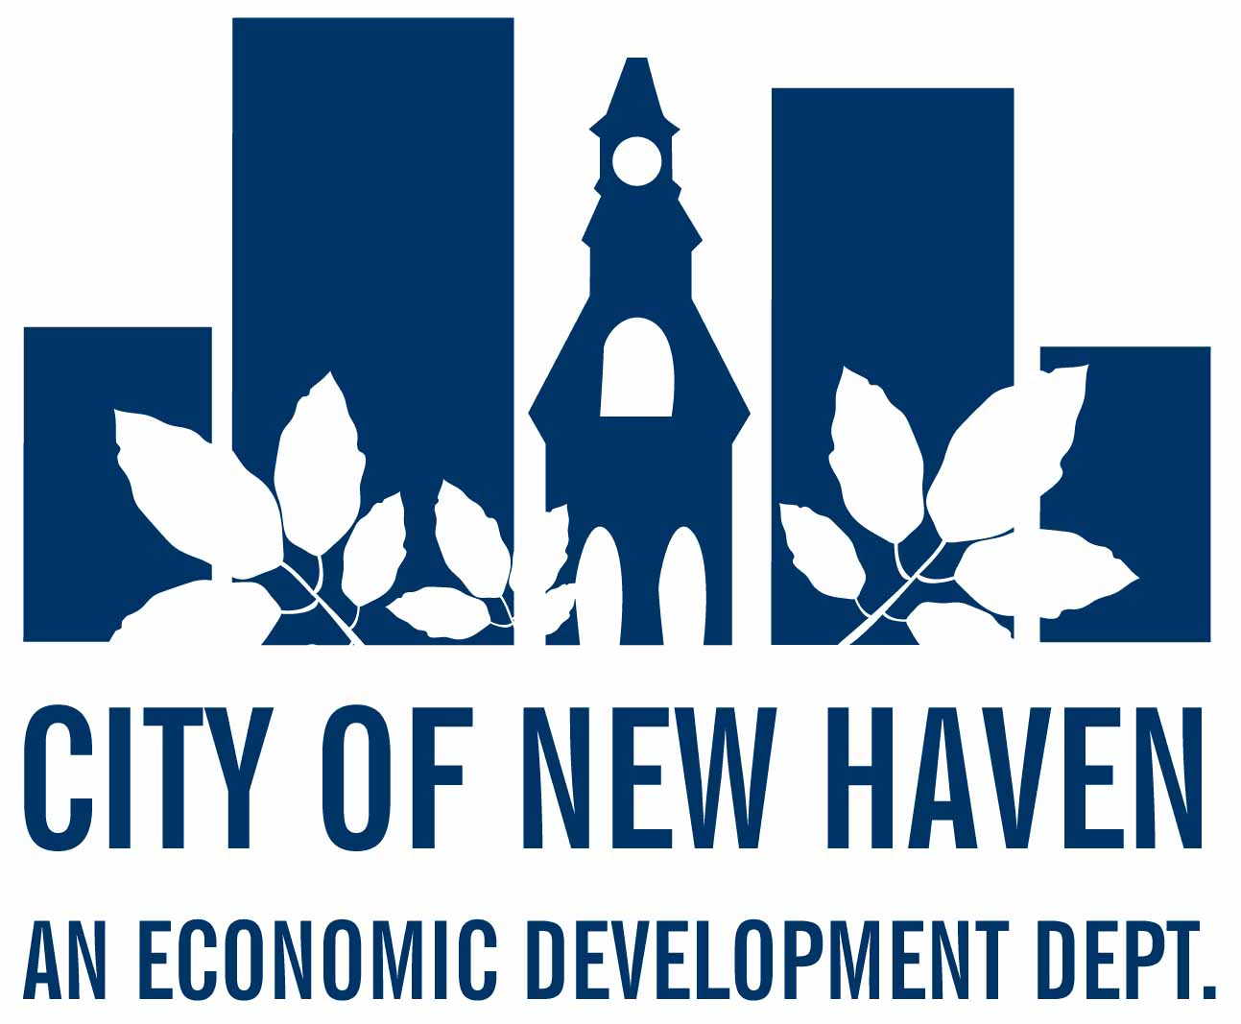
Arlevia T. Samuel  Executive Director |  | Michael Piscitelli  Economic Development Administrator
ANNUAL MEETING SCHEDULE FOR 2023

The Property Acquisition & Disposition Committee (PAD)
will hold Regular Meetings Via Zoom at 3 P.M. on the following days:

January 18, 2023 July 19, 2023 January 17, 2024
February 15, 2023 August 16, 2023
March 15, 2023 September 20, 2023
April 19, 2023 October 18, 2023
May 17, 2023 November 15, 2023
June 21, 2023 December 20, 2023

WEB-BASED MEETING HOSTED ON ZOOM. Note: Since the meeting is remote, participation by a quorum of members is expressly prohibited at the physical location and will not be present however any member of the public may request, in writing, a physical location and “any electronic equipment necessary” to attend the meeting in real time no later than twenty-four (24) hours prior to the meeting. Said individual shall have the “same opportunities to provide comment or otherwise participate” in the meeting as would be afforded if the meeting was held in person with the following exception: Under law, if such person loses the ability to participate because of an interruption, failure or degradation of such person’s connection to the meeting by electronic equipment the committee is not required to adjourn or postpone the meeting. Please contact Evan Trachten, Livable City Initiative Acquisition & Disposition Coordinator: etrachte@newhavenct.gov Office (203) 946-8373

